
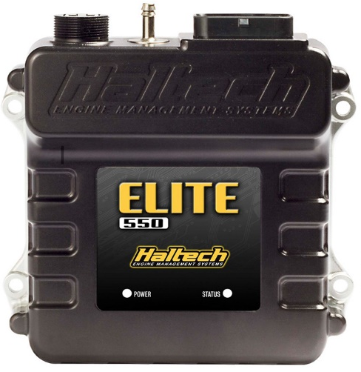
The below document outlines the required software and procedure for connecting to the Haltech Elite550 ECU as supplied with the Kavinci Motors / Krash Industries 1162 PFI Engines.
Haltech ESP software and our custom definition file are required to connect to the ECU properly and are detailed bellow.

Software:
Haltech ESP 2.57.0 or later
https://www.haltech.com/downloads/

Custom ECU Definition & Firmware:
File: Elite550_02.45.03.202_571.hdef
Location: This PC → Documents → Haltech → Definitions
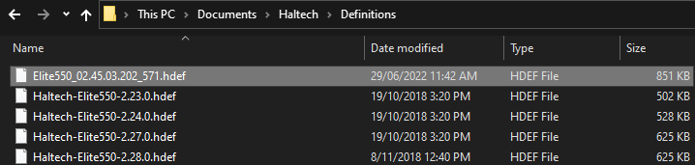

File: Haltech-Elite550-2.45.3-Experimental2_571.hfmp
Location: This PC → Documents → Haltech → Firmware

Connecting to the ECU:
- Using a USB-A to USB-B cable (as pictured below), connect to both the USB port on the Haltech ECU and the computer with Haltech ESP 2.57.0 software installed.
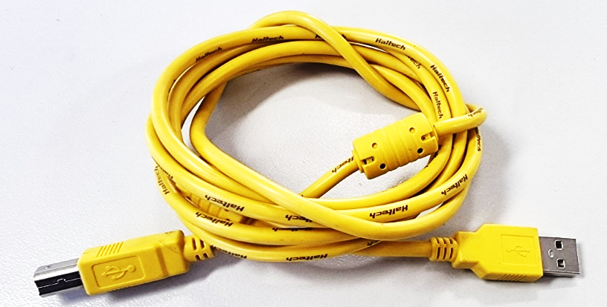
- Turn power on the ECU (ski power button)
- Open the Haltech ESP 2.57.0 software
- Close the “Access ESP Online” prompt, this is not required
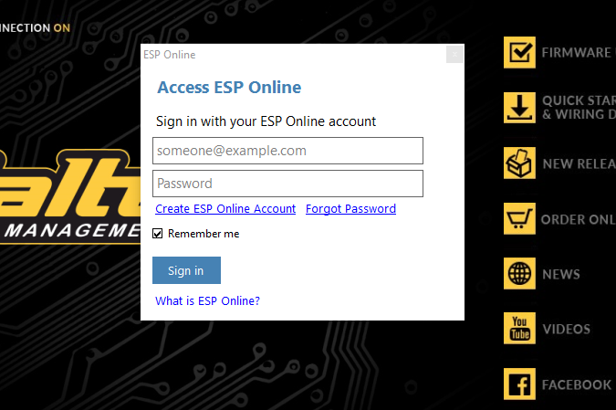
- Press the Connect button, as shown bellow
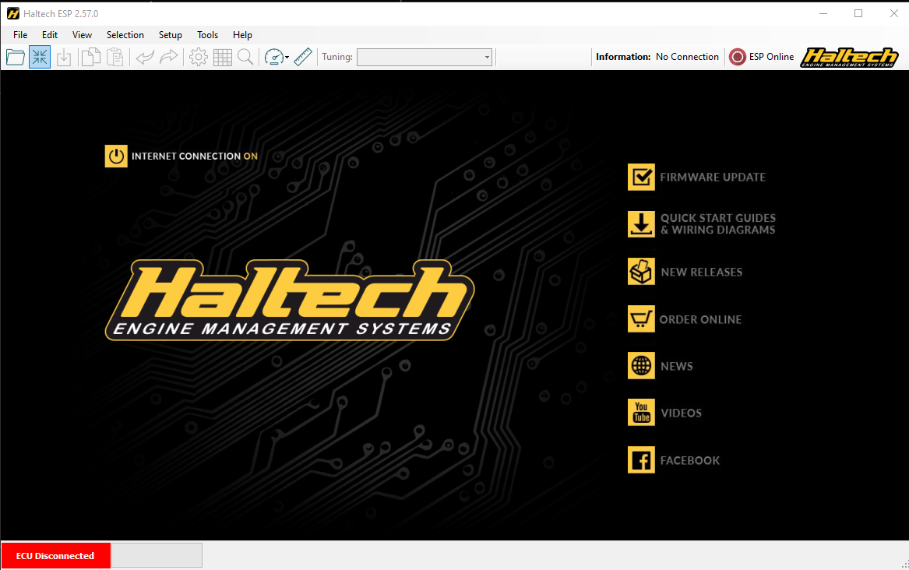
- When a connection is made with the ECU, the bottom left status bad will change to blue and state “ECU Connected”
Updating the Firmware:
- If the firmware needs to be reset to our custom firmware (Haltech-Elite550-2.45.3-Experimental2_571.hfmp), it is updated through the below tab after connecting to the ECU.
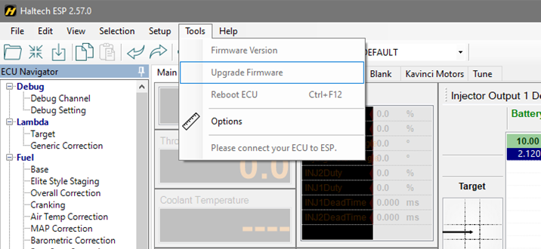

Updating the ECU Map:
- To upload the Map file, when connected to the ECU, navigate to the “File” tab and select “Upload Map”
- This will bring up a window where you can navigate to where you have placed the map file, select “open” and the map will be uploaded.
- The ECU may require a power cycle after a new map has been loaded.
- After a new map has been loaded, the Throttle Position Senor will always need to be re-calibrated.
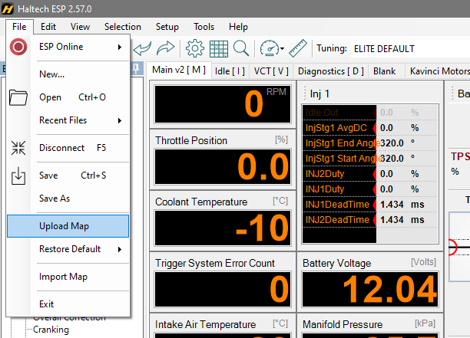

Setting the Throttle Position Sensor:
- Select the “Main Setup” icon along the top bar of the software
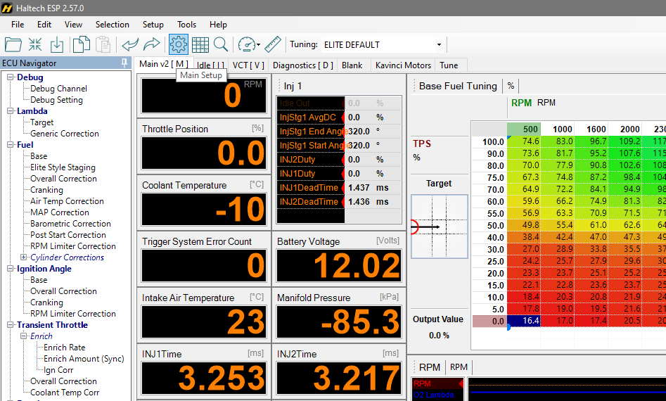

- Select the “Functions” side tab
- Scroll down and select the “Throttle Position Sensor”
- Select the “Calibration” tab
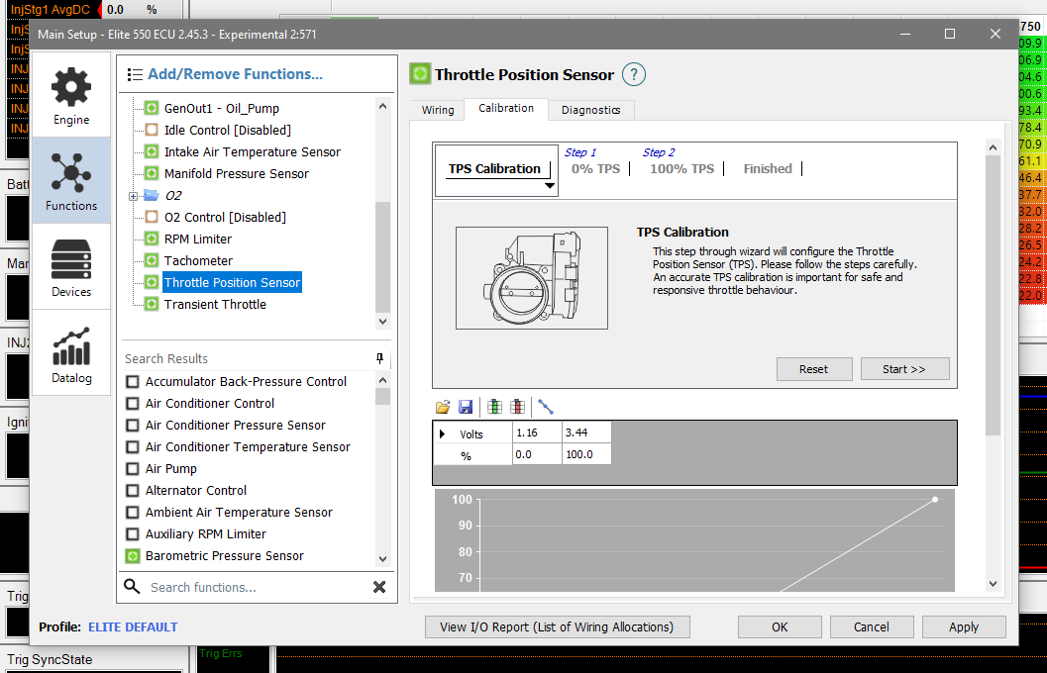

- Select “Start > >” to begin the calibration process.

- With the throttle butterflies fully CLOSED, press the “Calibrate” button to set eh 0% TPS position.
- Note that the butterflies need to be fully closed, this requires backing off the idle adjustment bolt near the throttle cable to insure they are not being held open. If this is not preformed properly, the Map and throttle position sensors will be completely misaligned.
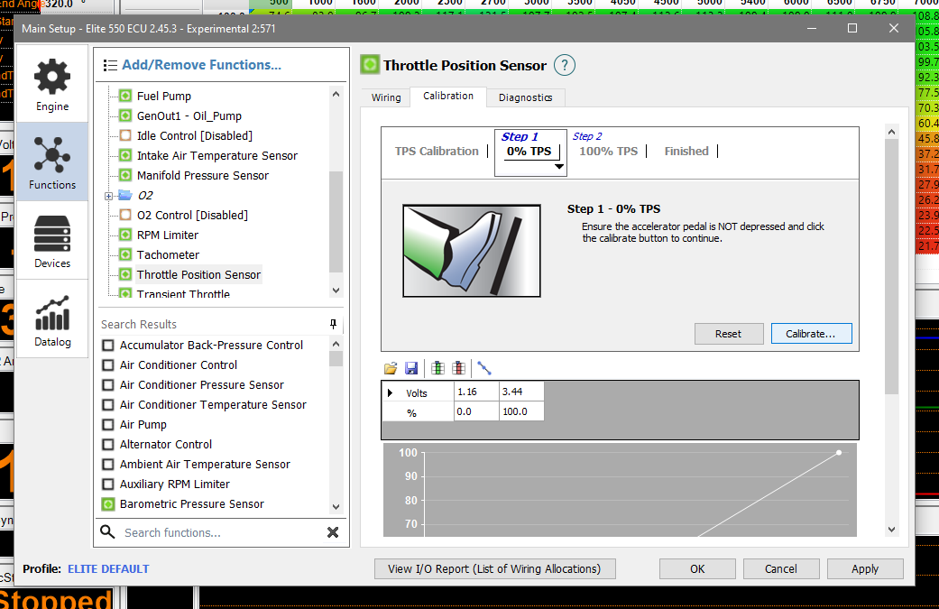

- With the throttle butterflies fully OPEN, press the “Calibrate” button to set eh 100% TPS position.
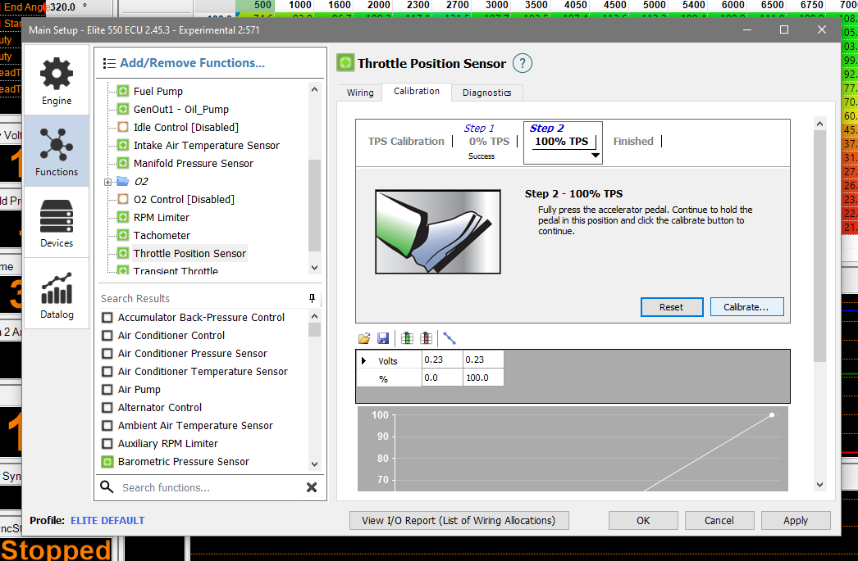

- The throttle position sensor is now calibrated, press “OK” to exit the menu
- Be sure to reset your idle position screw back to approximately 13%
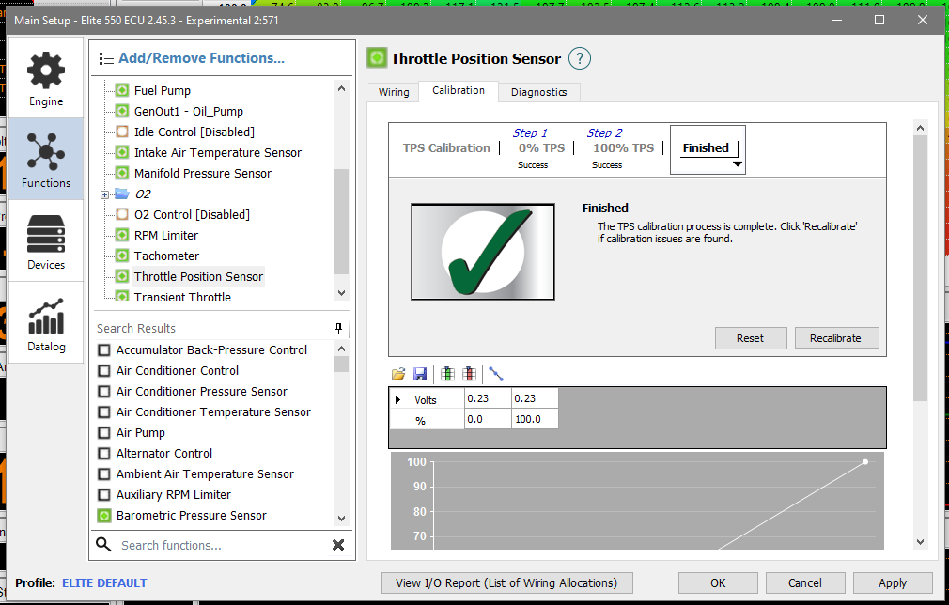

Clearing the Logged Data:
- To clear any previously logged data, firstly select the “Data Manager” tab.
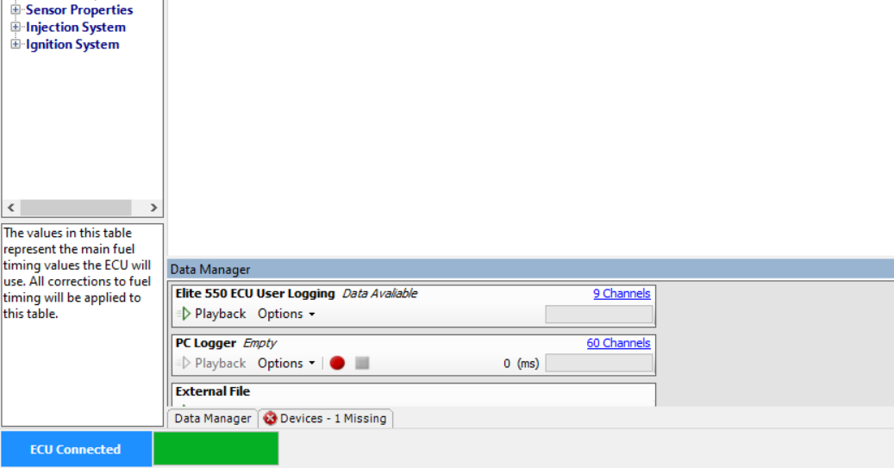

- Select “Options” and then “Clear”
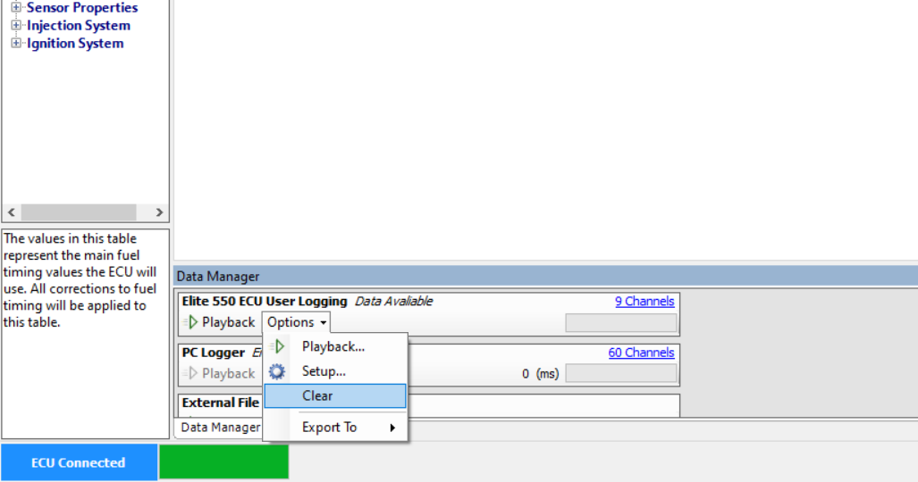

- The status of “Empty” will then be displayed.
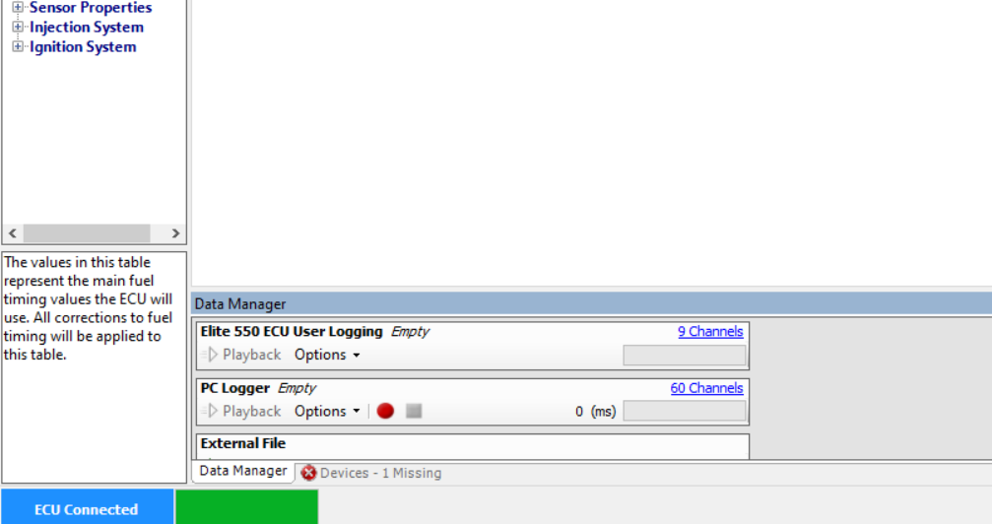
Retrieving the Logged Data:
- To retrieve and save logged data, firstly select the “Data Manager” tab.

- Select “Options”, “Export To” and “File…”
- Select the fold you would like to save the data and name the file (preferably date and vehicle).
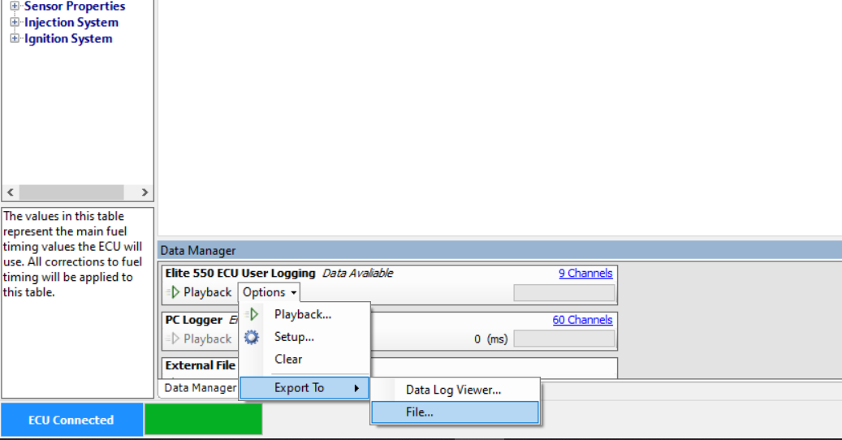

- Be sure to clear the data after downloading, Haltech only has a very limited data logging capability and can fill up very quickly. Clearing data will help prevent data from being missed.

