Dear Krash Industries Customers,

I want to inform you about the seven lost watercrafts originally consigned to JS Powersports on 24th of December and shipped out of port on 31st December (see list below).

FOOTROCKET PRO 21 | PRO - Black (F) | KRAFR4 P1G121
FOOTROCKET PRO 21 | PRO - Orange (F) | KRAFR4 P2G121
FOOTROCKET 2021 | Light Blue / Lime (S) | KRAFSL 02H121
FOOTROCKET 2021 | Acid Green / Purple (S) | KRAFSL 04H121
FOOTROCKET 2021 | Hot Pink / Light Blue (S) | KRAFSL 03E121
FOOTROCKET 2021 | Orange / Grey (S) | KRAFSL 05E121
FOOTROCKET 2021 | Hot Pink / Light Blue (S) | KRAFSL 04E121

After numerous phone calls and emails, we were informed by the master shipper Yangkee sea freight that their co-loader had somehow incorrectly shipped the consignment to Bangladesh.
The seven watercrafts are now in a government bond store. We have been trying to get the shipper to have the skis released and airfreighted to the original destination in the US. The shipper has advised us that because the skis were originally sent by sea then they must be exported out of Bangladesh by sea. The shipper now will have the skis returned to Thailand by sea (10 days voyage) after which we will airfreight the consignment to Chicago on the 14th of May.

I sincerely apologise for the inconvenience this caused and assure you we are doing absolutely everything we can to resolve this incident ASAP.

Regards,

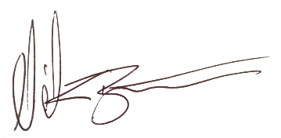

Nicholas Barton
CEO Kavinci Motors T/A Krash Industries

